If you do not already have ArcGIS Pro installed on your computer, go to the Installing ArcGIS Pro section at the end of this document for instructions on installing the program.

Creating a New Project
- Start ArcGIS Pro | 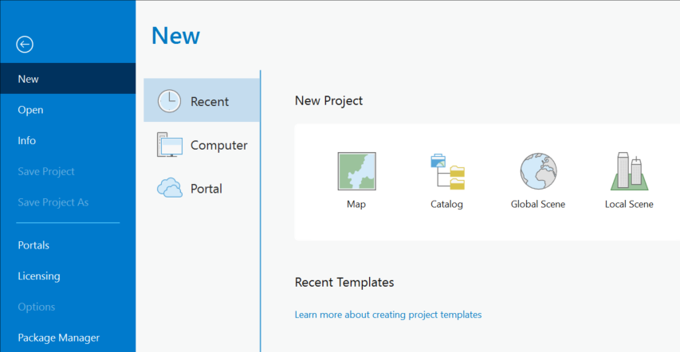
- Select the Map icon under the New Project section
- Follow the prompts to name your project and specify location.  - Press OK. | 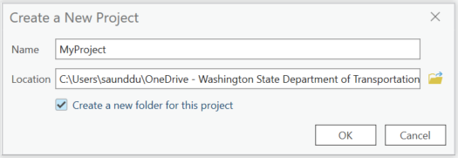
This will create your Arc GIS Pro project and a map of the United States will appear.
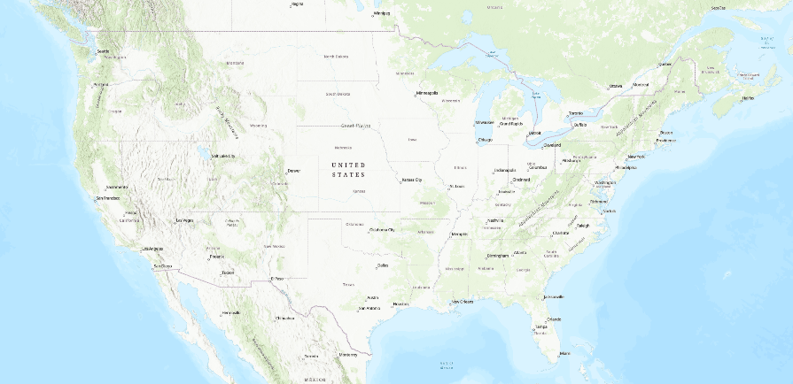

Load the WSDOT Basemap
- Select WSDOT from the top menu  - Select Tools from the ribbon | 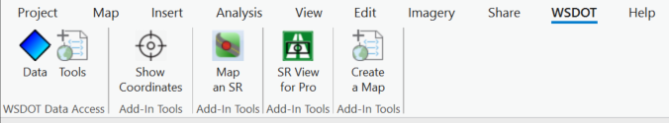
- Select Load WSDOT Basemap from the popup dialogue box.  - Click Apply |  | 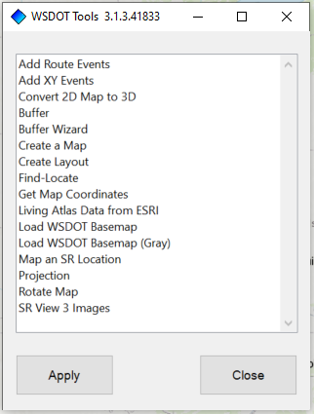
Note: The WSDOT Basemap may take several minutes to load.
Once the new Basemap is loaded, your computer screen will display a Washington State map as shown below:
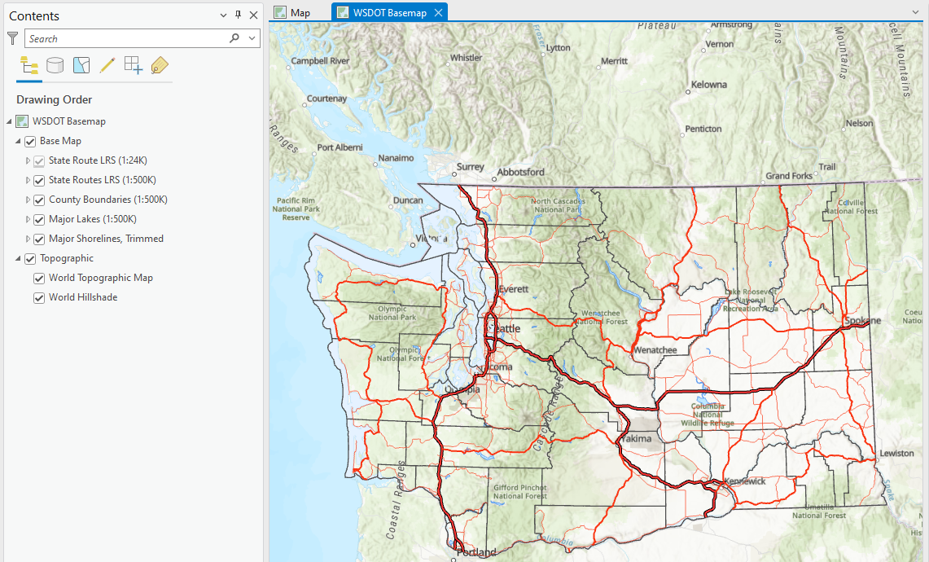

Add Guardrail Point Data
- select WSDOT from the top menu
- click the blue diamond DATA button on the ribbon
The Select Business Area/ Select Dataset menu will pop up. Under the Select Business Area menu
- Select WSDOT GeoData Catalog from the drop-down menu.
- Expand the Source Data by Subject folder under the Select Dataset menu.
- Scroll down and expand the Transportation Features and Roadside Safety Barriers folders.
- Select the Guardrail Points folder.
- Press the Add Data button.
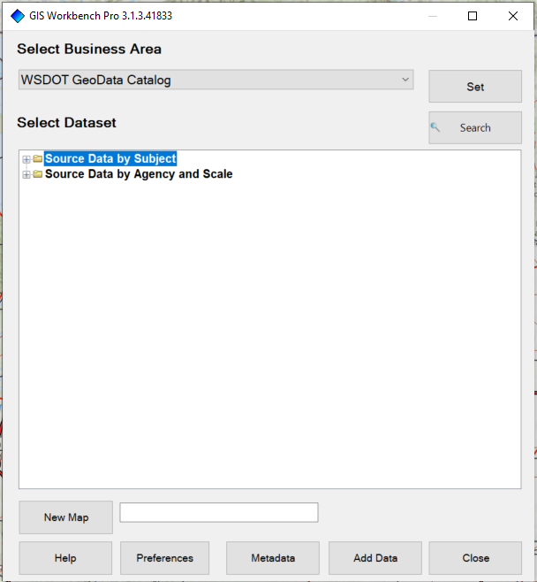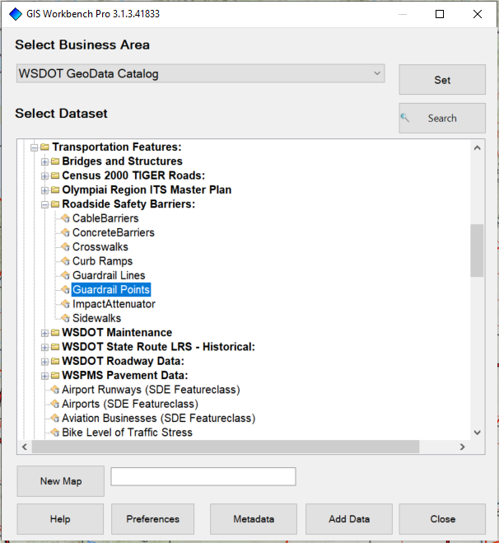
Note: It can take several minutes to load in the guardrail points data.
You will know that the guardrail points data is loaded when the Guardrail points group comes up in the Contents window. Note: Guardrail terminal source data in the GIS workbench was compiled by the HQ Design Safety & Innovation Office, October 2023 (at the time of drafting this document).
After the guardrail points data loads:  - Close the Select Business Area window.  - On the left side Contents sidebar, check the box next to Guardrail Points layer. |  | 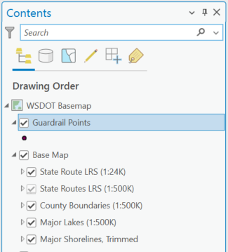

Build a Selection Set of Guardrail Terminals

Selecting Mainline Terminals
- Select Map from the top menu.  - Select Select By Attributes from the ribbon. | 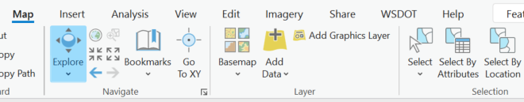
The Select By Attributes window appears.  Use this window to build a selection set by entering the following in the dialogue box:  - Specify State Route:  - Click the dropdown menu located next to the Where.  - Select RouteIdentifier and set RouteIdentifier equal to the desired State Route.  Note: SR Route uses 3 digits (i.e. US 101 = 101, I-90 = 090, I-5 = 005, etc.)  - Set Beginning Milepost:  - Click + Add Clause.  - Select StateRouteMilepost and add a clause to the expression to set. StateRouteMilepost is greater than or equal to the beginning milepost for the project.  - Set Ending Milepost:  - Click + Add Clause.  - Select StateRouteMilepost and add a clause to the expression to set. StateRouteMilepost is less than or equal to the ending milepost for the project.  - Click Apply  This may take several minutes to load. |  | 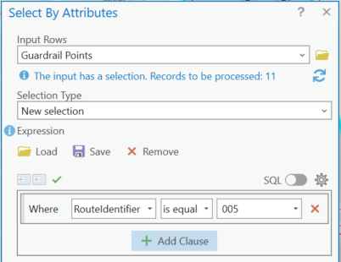  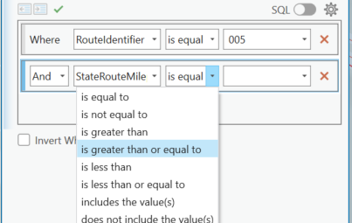  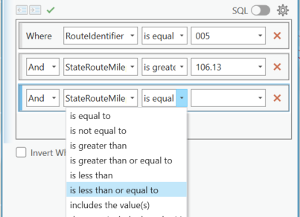
If your project has multiple milepost ranges (e.g., there are exceptions, multiple State Routes, etc.), repeat the previous process starting with step 20 but change the Selection Type to Add to the current selection. Select your next SR and Mile Post range and select apply. You may add as many ranges as needed. |  |  | 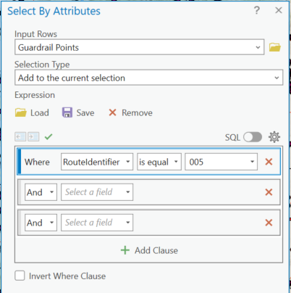
When you are done adding to the selection, click OK.
The map will highlight your chosen Guardrail Points in blue on the basemap.
If you don’t see anything highlighted in blue, zoom out until you can.
This process will only select guardrail points along the mainline route. If you zoom in on your terminal selection, you will notice that only the points along the State Route mainline are highlighted, but none of the points along the ramps are highlighted.
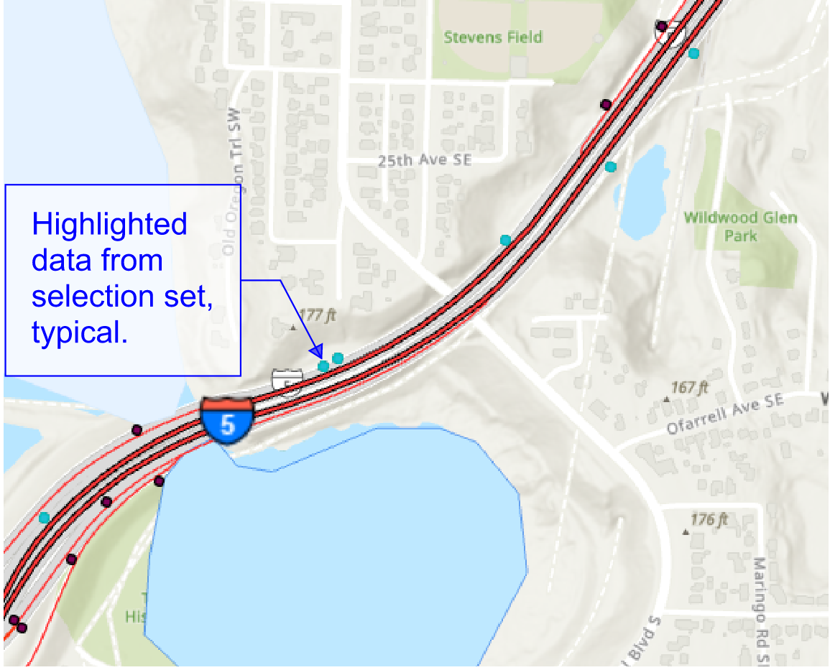
If the only guardrail terminal inventory information you need is on State Route mainline, skip to Export Data to Excel (Step 42).
In order to select points on ramps you will have to create a polygon note around any non-mainline guardrail points you want to include. To do this, follow steps 24 – 41 in the Selecting Guardrail Points on Ramps section below.

Selecting Guardrail Points on Ramps
Follow the steps below if additional terminal inventory information is needed outside the State Route mainline (such as guardrail terminals located along ramps). Also, the WSDOT Interchange Drawing Viewer – is an additional resource that may be helpful when ramps are involved.
- Select Insert from the top menu.
- Click the down arrow on the right sidebar of the Layer Templates frame in the ribbon.
- Select the Polygon Map Notes icon.
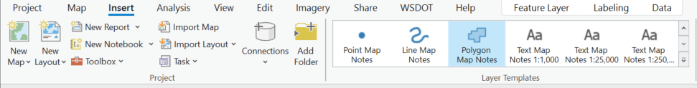
A layer named “Polygon Notes” will be created in the Contents menu on the left.  - Select the Polygon Notes layer in the Contents menu |  | 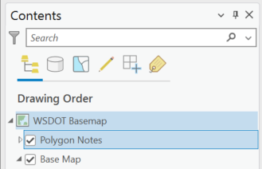
- Select Edit from the top menu.  - Click on Create in the Features group on the Ribbon. | 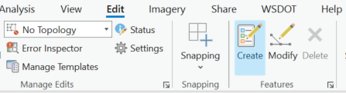
The Create Features dialog box will open in the right sidebar.  - Click on Polygon Notes in the Create Features dialog box.  - Select the polygon icon from the drop-down set. |  |  | 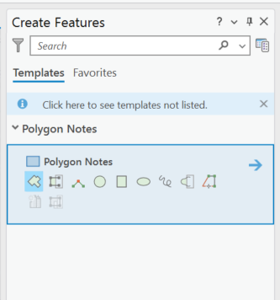

- Place polygon vertices around the highlighted points in your selection set to encompass the project limits.
Example:
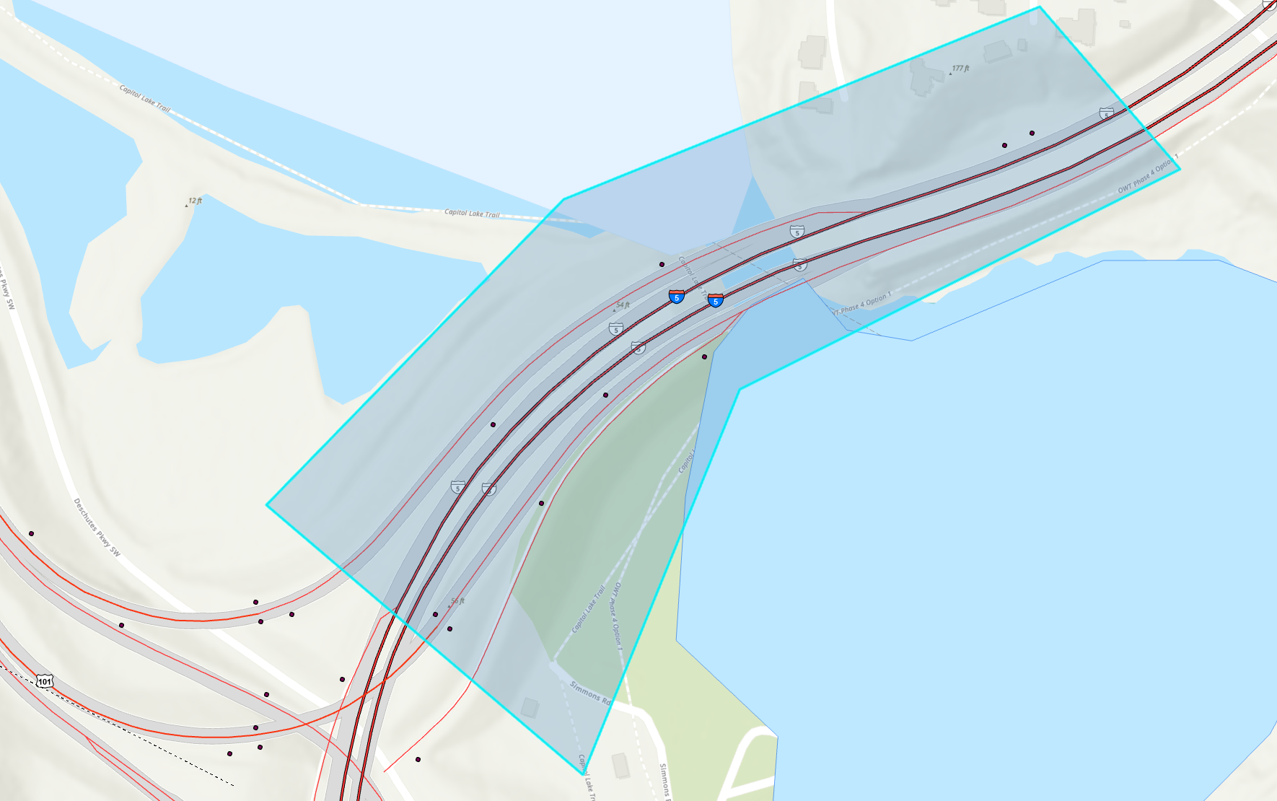
If your project has multiple milepost ranges (e.g. there are exceptions, multiple State Routes, etc.), create the boundary around one range or part at a time. Be sure to include any data points not highlighted (e.g., points on adjacent ramps that the project requires).
After placing the last vertex of the selection polygon:  - Right-click and a dialogue box will pop up at the cursor.  - Create as many polygons as required to select everything you need data for.  - Use Finish Part for each polygon you create.  Note: avoid clicking Finish, which is just above Finish Part, until you have placed your final polygon.  Once you have placed the last vertex for the final polygon:  - Right-click and select Finish to complete your final polygon. |  | 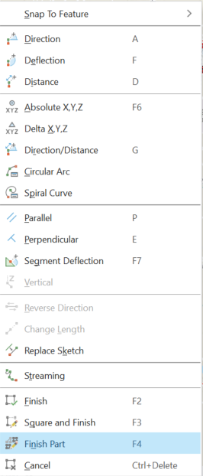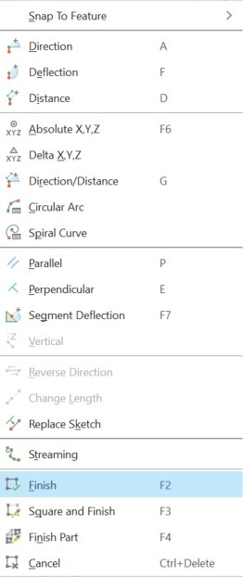
After you have created your final polygon  - Select Map from the top menu.  - Select Clear in the Selection frame on the ribbon. | 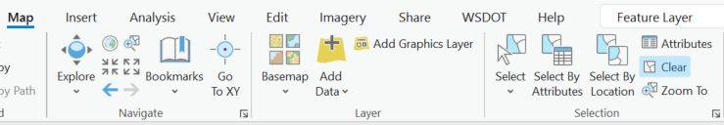
- Click on the Select By Location icon in the Selection frame on the ribbon. | 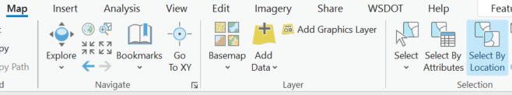
The Select By Location dialogue box will open.  - click on the Input Features drop down menu and select Guardrail Points.  - Click on the Relationship drop down menu and select Intersect.  - Click on the Selecting Features drop down menu and select Polygon Notes.  - Make sure to save any pending edits (if they appear) by clicking the Save Edits icon at the top of the dialog box.  - Click OK. |  |  | 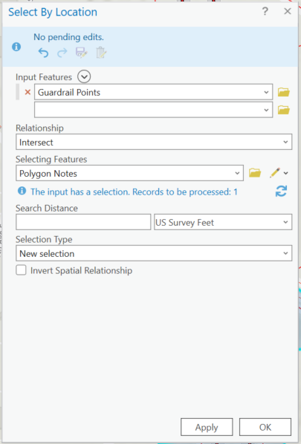
The Select By Location query will run and produce a selection set from the data within the bounds of the shapes on the Polygon Notes layer on the map.
You are now ready to export your results to an excel spreadsheet.

Export Data to Excel
- In the search bar located at the top of your computer screen, type in “Table to Excel” and load the conversion tool. |  | 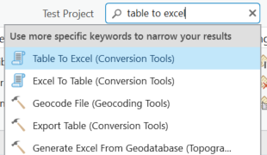
This may take several minutes to process. Once export features have been processed, the Geoprocessing menu will pop up on the right side bar.
Under the Geoprocessing menu:  - Select the Input Table drop down list and click on your selected Guardrail Points feature  - select Output Excel File and designate a location where you want to save your excel sheet  - click Run at the bottom of the Geoprocessing menu. |  |  | 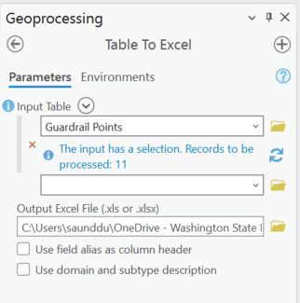
Once Step 8 is completed, you may retrieve your excel file from the location you specified. | 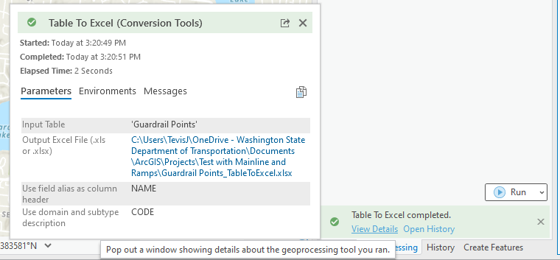
Note:
Contact Kevin Burch at HQ Design if further assistance is needed to get terminal inventory data.

Excel Spreadsheet Data
When you open your excel spreadsheet, it will display the selected guardrail terminal inventory (in rows 2 and lower), and it will display information about each guardrail terminal (in columns A thru R). The columns you will be interested in are:
Column C: RouteIdentifier – Name of the route (###) or of the ramp (###L######).
Column D: EndTreatmentType – Guardrail terminal feature description.
Column P: StateRouteMilepost – State Route Milepost of the terminal.
Column Q: AheadBackIndicator – Ahead/Back Indicator.
Clean Up: See Excel clean up steps below spreadsheet.
Example below: (Route Identifier, EndTreatmentType, and StateRouteMilepost are shown in this example and likely to be the most relevant fields)
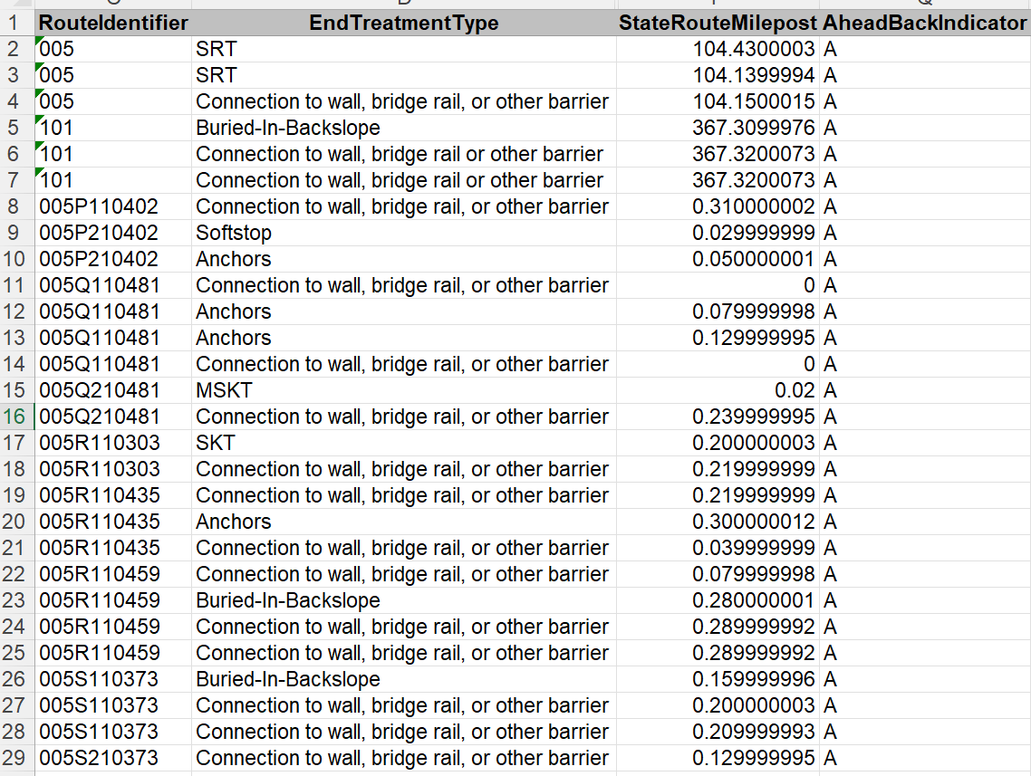

Excel Clean Up Steps
First, you might want to change the number format of column “E” to (Number with 2 decimal places) by selecting column “E”, right-clicking, and selecting “Format Cells”. Then using the settings below:
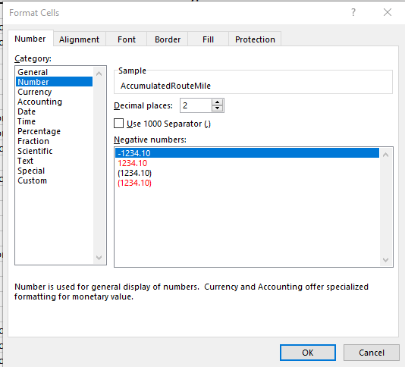

Also, sort the spreadsheet by first column “C” then by column “E” by choosing Data and then choosing Sort.
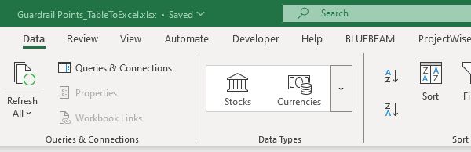

Then make these settings. Hit OK on this.
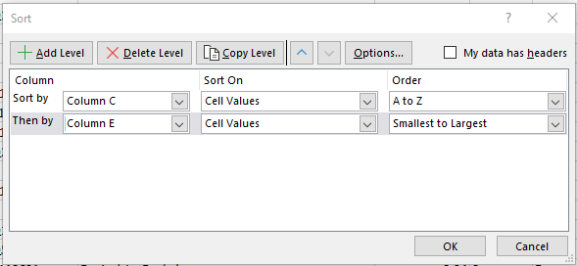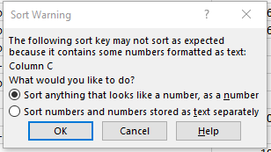

Now the Spreadsheet should look something like this. Notice the Routes come before the ramps.
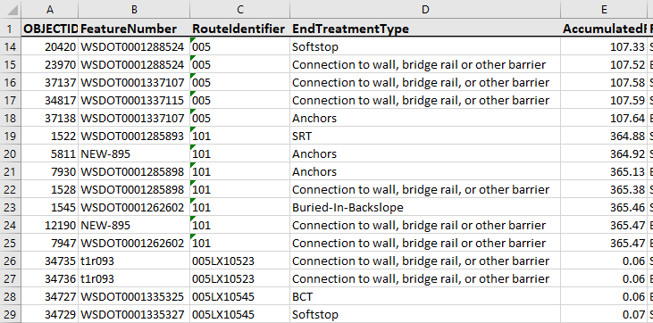

Installing ArcGIS Pro
To install ArcGis Pro, type “software center” into the windows search bar at the lower left corner of your windows desktop and click on the Software Center App in the “Best match”results to open SoftwareCenter. | 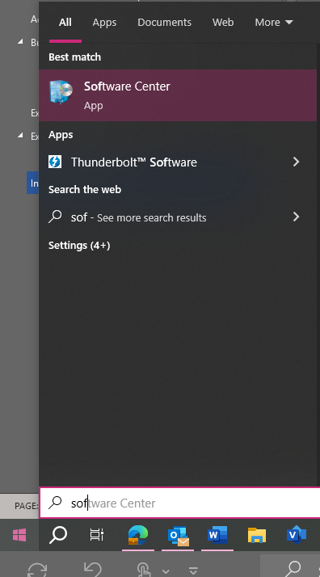
- In the Software Center, select the Applications tab on the left sidebar
- Locate and click on the ArcGIS Pro icon.
- If it isn’t listed in the featured apps, search for AcrGIS in the search in the upper right in the Software Center app.
- Click on the Install button to download and install.
Note: It will take several minutes to install the ArcGIS Pro program.
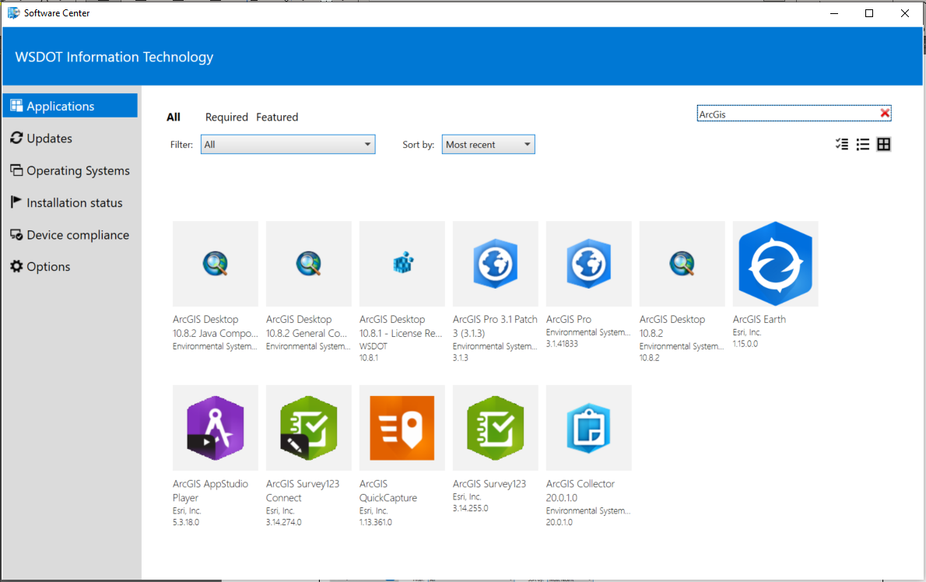
Contact IT support if you need further assistance with installation.

